HW1: Mid-term assignment report

*Gabriel Hall Abreu [102851]*, 2023-04-10

1 Introduction 1

1.1 Overview of the work 1

1.2 Current limitations 1

2 Product specification 2

2.1 Functional scope and supported interactions 2

2.2 System architecture 2

2.3 API for developers 2

3 Quality assurance 2

3.1 Overall strategy for testing 2

3.2 Unit and integration testing 2

3.3 Functional testing 3

3.4 Code quality analysis 3

3.5 Continuous integration pipeline [optional] 3

4 References & resources 3

<All remarks like this should be removed from the final document!

This a template for the expected **content/structure**. You may use any editing tool to prepare the report (LaTeX included).

Feel free to write in Portuguese or English, but do not mix languages between headings and body…>

# Introduction

## Overview of the work

This report presents the midterm individual project required for TQS, covering both the software product features and the adopted quality assurance strategy.

AirQuality web app aims to present to the user the current air pollution for a given city of a given country.

## Current limitations

Cache system not implemented.

No error messages are being displayed if the api doesn’t find any information for the given inputs.

# Product specification

## Functional scope and supported interactions

The only scenario for my web app is when a user wants to get the current air pollution of a certain city.

## System architecture

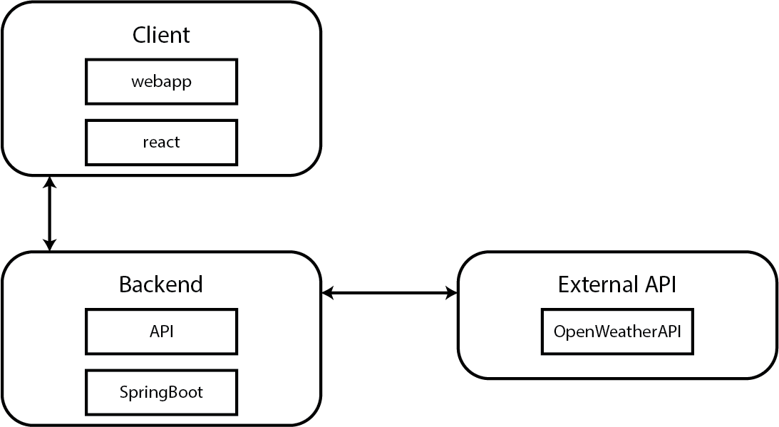

## API for developers

<what services/resources can a developer obtain from your project? document your API endpoints>

<note: for the homework, you are expected to expose two “groups” of endpoints:

* Problem domain: get the environmental data data by region/city, etc.
* Cache usage statistics: how many hits/misses,… >.

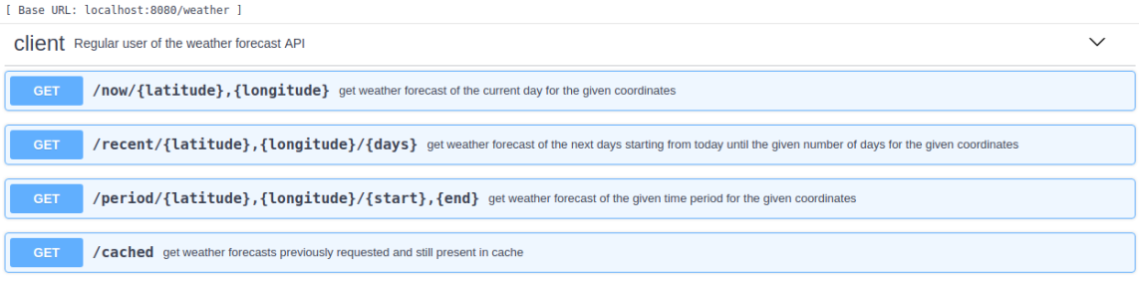

# Quality assurance

## Overall strategy for testing

[what was the overall test development strategy? E.g.: did you do TDD? Did you choose to use Cucumber and BDD? Did you mix different testing tools, like REST-Assured and Cucumber?...]

## Unit and integration testing

[where did you use unit and integration test? for what? which was the implementation strategy?]

[may add some screenshots/code snippets for clarification]

## Functional testing

[which user-facing test cases did you considered? How were they implemented?]

[may add some screenshots/code snippets]

## Code quality analysis

[which tools/workflow did you use to for static code analysis? Show and interpret the results.]

[you may add some interesting lessons learned, e.g., some code smell reported by the tool that was difficult to spot and otherwise you wouldn’t address it]

## Continuous integration pipeline [optional]

[did you implement a CI pipeline? What was the setup? Illustrate with screenshots, if applicable]

# References & resources

Project resources

|  |  |
| --- | --- |
| **Resource:** | **URL/location:** |
| Git repository | <link to your TQs repo> |
| Video demo | < short video demonstration of your solution; consider including in the Git repository> |
| QA dashboard (online) | [**optional**; if you have a quality dashboard available online (e.g.: sonarcloud), place the URL here] |
| CI/CD pipeline | [**optional**; if you have th CI pipeline definition in a server, place the URL here] |
| Deployment ready to use | [**optional**; if you have the solution deployed and running in a server, place the URL here] |

Reference materials

<document the key components (e.g.: libraries, API) or key references (e.g.: blog post) that were helpful and certainly **would help other students pursuing a similar work**>